**SYMBIOSIS INSTITUTE OF TECHNOLOGY**

**FUNDAMENTALS OF DATA STRUCTURES**

**LAB ASSIGNMENT 5**

**SEARCH ALGORITHMS**

**NAME:HARSH SACHIN CHANDEKAR**

**PRN:19070122066**

**CLASS:CS A**

**DATE:23/09/2020**

Search algorithms binary and linear search

**CODE**

//fds lab assignment 5

#include<stdio.h>

#include<iostream>

#include<conio.h>

using namespace std;

void checkorder(int A[100],int n)

{

for(int i=1;i<n;i++)

{

if(A[i-1]>A[i])

{cout<<"array is not sorted\n bye.... ";

getch();

exit(0);

}

}

}

int binaryrecursion(int A[],int l,int n,int m)

{

int beg=l,end=n;

if(beg<=end)

{

int mid=(beg+end)/2;

if(A[mid]==m)

return mid;

if(A[mid]>m)

{binaryrecursion(A,l,mid-1,m);}

if(A[mid]<m)

{binaryrecursion(A,mid+1,n,m);}

else

return -1;

}

//return -1;

}

void binarysearch(int arr[100],int n,int m)

{

int beg=0,end=n-1,mid,flag=0;

while(beg<=end)

{

mid=(beg+end)/2;

if(arr[mid]==m)

{cout<<"element found at "<<mid+1;flag++;getch();return;}

if(arr[mid]>m)

end=mid-1;

if(arr[mid]<m)

beg=mid+1;

}

if(flag==0)

cout<<"element not found";

}

void linearsearch(int arr[],int n,int m)

{

int i=0,flag=0;

for(i=0;i<n;i++)

{

if(arr[i]==m)

{

cout<<"\nelement found at pos "<<i+1;

flag++;

}

}

if(flag==0)

{

cout<<"element not found";

}

}

//calling linear search function

void linear()

{

int arr[100],n,i,m;

cout<<"\n how many elements";

cin>>n;

cout<<"\nenter elements \n";

for(i=0;i<n;i++)

{

cin>>arr[i];

}

cout<<"\nwhich data you have to search ";

cin>>m;

linearsearch(arr,n,m);

}

//calling binary search

void binsearch()

{

int arr[100],n,i,m;

cout<<"\n how many elements";

cin>>n;

cout<<"\nenter elements in sorted manner(ascending only)\n";

for(i=0;i<n;i++)

{

cin>>arr[i];

}

cout<<"\nwhich data you have to search ";

cin>>m;

checkorder(arr,n);

binarysearch(arr,n,m);

}

//calling for binary recursion function

void binrec()

{

int arr[100],n,i,m,b=0;

cout<<"\n how many elements";

cin>>n;

cout<<"\nenter elements in sorted manner(ascending only)\n";

for(i=0;i<n;i++)

{

cin>>arr[i];

}

cout<<"\nwhich data you have to search ";

cin>>m;

checkorder(arr,n);

b=binaryrecursion(arr,0,n-1,m);

if(b==-1)

cout<<"\nthe element is not present in array\n";

else

cout<<"element found at position "<<b+1;

}

main()

{int x;

cout<<"enter your choice \n1.linear search\n2.binary search (linear)\n3.binary search(recursion)";

cin>>x;

if(x==1)

linear();

if(x==2)

binsearch();

if(x==3)

binrec();

}

**OUTPUT**

Linear search

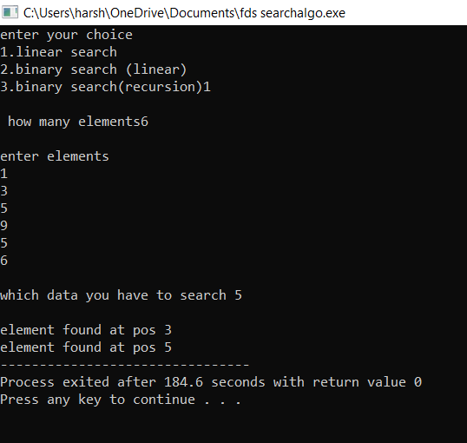

Binary search(iterative)

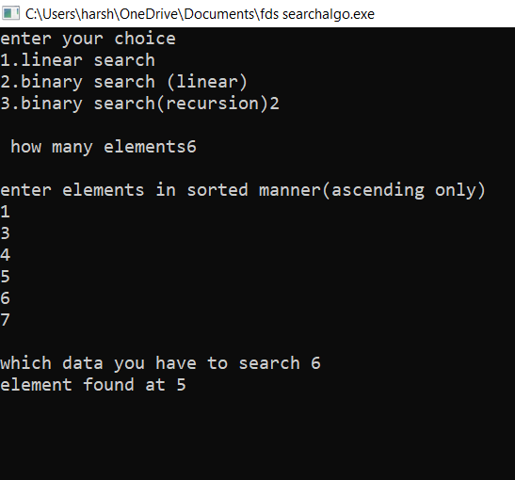

Binary Search(recursive)

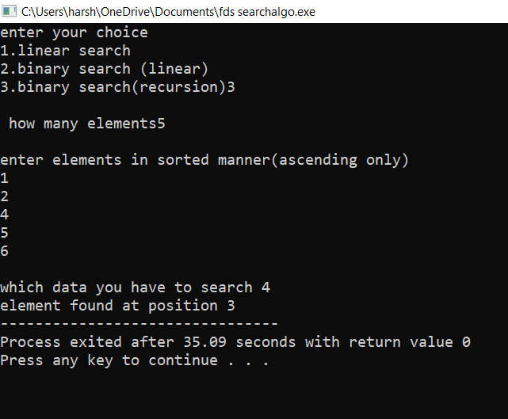

**Thank you!!**